Posted 10/25/2011 at 2:44 pm by JAV

Municipal Building Committee

Agenda
Volunteers Hall
Wednesday, Nov. 2, 2011
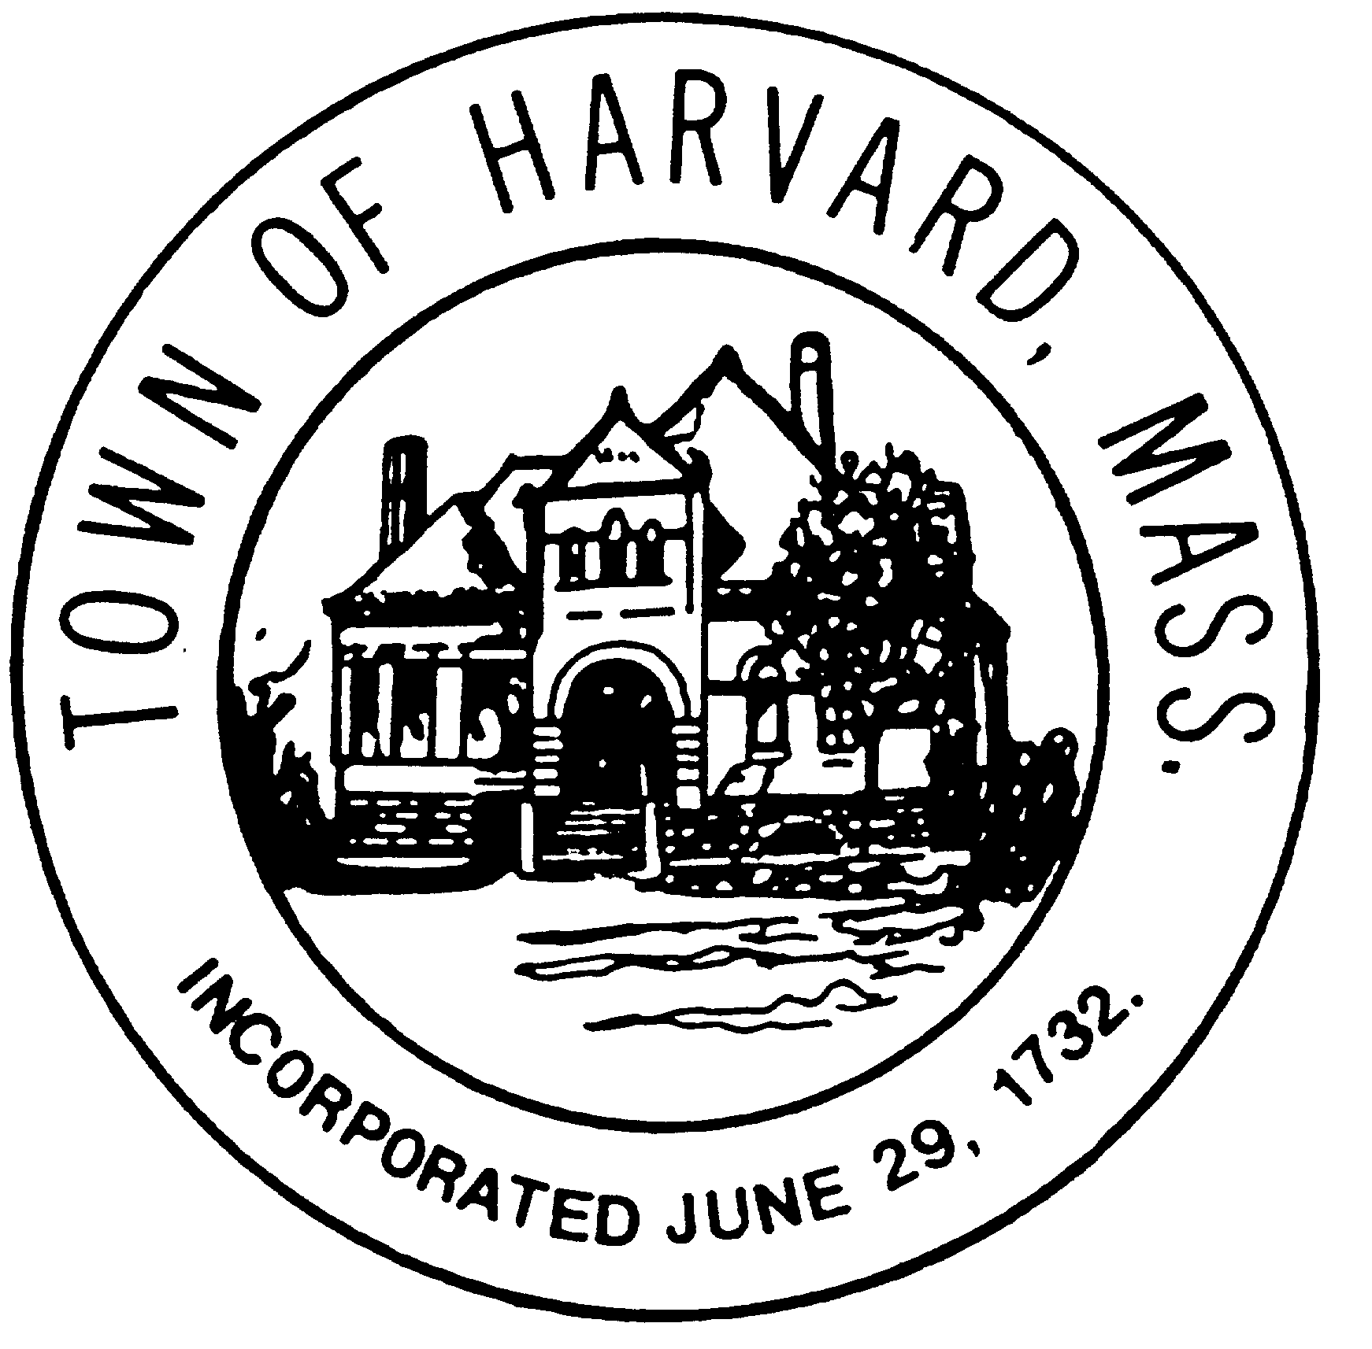
6:00 PM

- Interview architects

- Select architect firm

- Agenda for next meeting

